Project Report
NAME: REN FEIYANG
SID: 59304550
COURSE CODE: CS3201

I wrote codes for both Client Side and Server Side, and the functions keep the same as requirements expected. Here I uploaded 2 screen shoots for each side. All the methods are perfectly realized, and the running outcomes are demonstrated below.

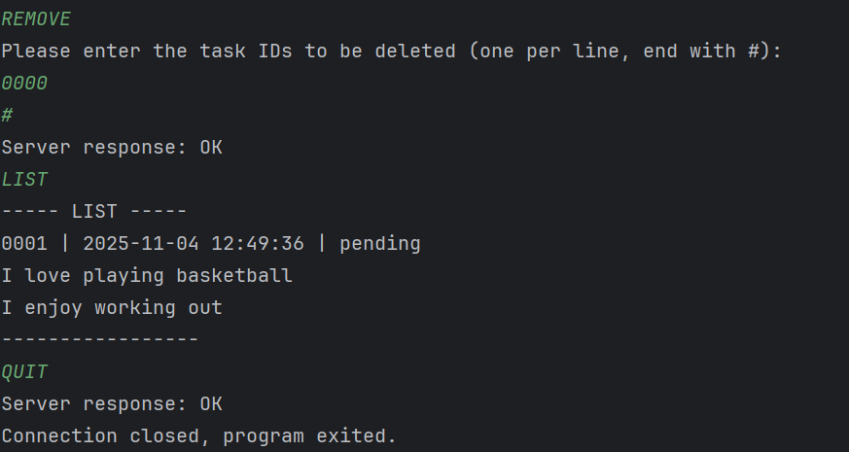
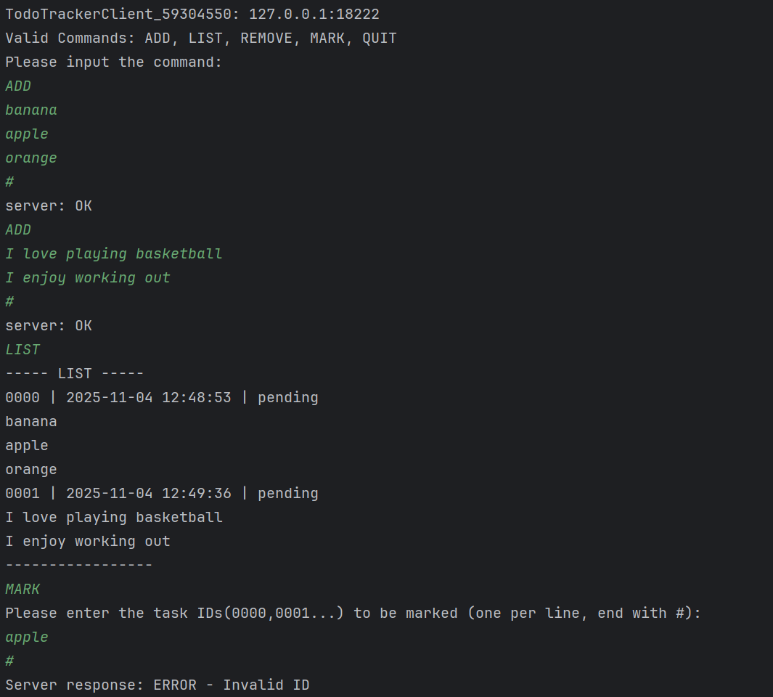
Screen Shoot (Client Side):
Screen Shoot (Server Side):
